Self-esteem and Confidence Building
Find a more positive self-image
A brief, ‘no nonsense’ self-help guide with easy to follow exercises and coping strategies to kick start your confidence and self-esteem.
Carole Gibson – Learner Services GIG
6/4/2016

Contents Page

Self-esteem and confidence building 3
Basic human rights 4
Barriers to developing self-esteem 5
Developing a health level of self-esteem 6
Positive self talk 7
Ten tips to higher self-esteem 8
Confidence boosters 9
Feel good about yourself 10
Assertive power 11
Affective communication 12
Checklist 13
References 14

Self-esteem and Confidence Building

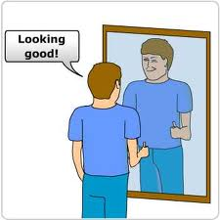

How do you know if you have self-esteem?
One way to consider how much self-esteem you have is to look at how well you recover from disappointments, failure or a set-back
Do you tend to:
Withdraw; blame others; develop a 'poor me' attitude; get quite depressed; consume too much alcohol; eat too much; or give up?
Or are you the sort of person who gets a bit emotional and then:
Analyses what went wrong and try to fix it; says "I'm OK, my actions were wrong in that instance": plans a step-by-step recovery; keeps a good balance in your life no matter what the circumstances?

What is self-esteem and how do we get it?
Self-esteem is about liking yourself and being confident about yourself. Having a healthy level of self-esteem can be a great help in getting you through life. With self-esteem comes confidence and vice versa.
Being confident and having a good level of self­ esteem will help you to be assertive about your rights, you will be more able to make decisions that suit you. You will be more able to communicate well and effectively. You will find that relationships with others will improve.
You get a better level of self-esteem & confidence partly by accepting yourself for who you are, your strengths and your weaknesses. This may be easy to say rather than do but with practice it may become easier.

Some things to think about:
- How well do you know yourself?
- What can you do to feel good about yourself? How do you handle problems & situations?
- How do you react when you have done something wrong or that you consider stupid?
- How well do you communicate with others? Do you know what your rights are?
Basic Human Rights
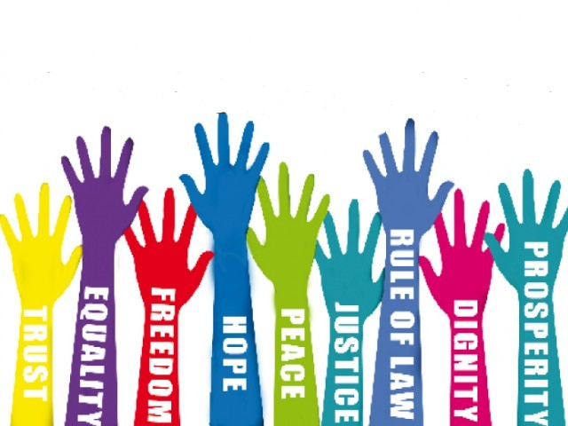

If I choose to, I have the right:

- To be treated with respect as an intelligent, capable and equal human being.
- I have my own opinions, feelings and needs and to be able to express them appropriately
- To ask for what I want whilst recognising that the other person has the right to say no.
- To make my own decisions and cope with the consequences.
- To say NO without feeling guilty.
- To make mistakes.
- To change my mind.
- To be listened to
- To deal with others without depending on their approval
- To disagree
- To be alone and independent
- To have privacy
- To say I don't understand and ask for me information
- To choose whether or not I get involved in someone else's problems
- To set my own priorities

There are many more that you can probably think of yourself

Barriers to developing self-esteem

Negative Self-Beliefs
These beliefs can come from negative verbal and non-verbal messages from people around us as we are growing up. Because these messages may have been delivered by an adult to us as a child we may well have thought that they are correct. It may be difficult to erase these negative messages but its not impossible. It is a matter of 're-programming' or to use a counselling term, 're­ framing', which is simply an alternative way of looking at things.

The Victim Trap
People who have the victim trap as a barrier to self-esteem project blame for what happens to them onto other people or things. This gives them an excuse as to why they cannot and do not feel good about themselves. This way of being in the world may well have come from how others treated you as children, you may have grown up with no other experiences.
Projecting blame onto other people and things when things are not going well in life often leads to negative and irrational thinking: "It's all their fault that I don't feel good about myself, they made me feel this way."

Lack of Enjoyment in the Things We Do
Having a negative outlook means we may be critical about the things we are doing, only ever seeing the dark side. This can lead to a sense of hopelessness.

Sense of Hopelessness
This is a belief that things are out of our control and must be left up to fate, so nothing good is likely to happen. Once we start to believe this we will stop involving ourselves and stop participating in things. The ability to get some positive feedback about ourselves then is much reduced. It begins a nasty circle of failure and low self-esteem that, once in to, becomes hard to break out of.

Depression anger and sadness
The sense of hopelessness we feel can lead to feelings of depression, sadness and anger. All these feelings can translate in to low levels of self-esteem. These feelings can lead to withdrawal or projection of blame
Withdrawal and Projection of Blame
Once we are depressed or feeling sad we tend to withdraw from situations. Anger mixed with sadness can be a good mixture for the blaming cocktail. We can get in to projecting blame, outwardly and inwardly because there is nowhere left to go. We are down on others and down on ourselves so nobody is any good. This projection of blame, inwardly or outwardly, then leads to ongoing negative and irrational thinking and a lack of nice things in life. We are caught in the cycle feeling trapped.
I hope that from the above points it is easy to see that there is a cycle of feelings that are hard to escape from, but it can be done.
It is also important to remember that we all feel those feelings sometimes, feel we lack confidence and our self-esteem is low, but there is hope that we can all break away from them and feel better about ourselves.

Developing a healthy level of self-esteem
I guess that right now you are wondering how you break out of the cycle and grow in confidence and self-esteem? Here are some ideas.
If your self-esteem is suffering due to a life event such as divorce, bereavement, family troubles or any issue that may be causing you to feel sad, depressed, anxious, stressed of confused it may help to access professional help, such as a counsellor or self-help group.
However, if you want to work on your self-esteem yourself here are a few thoughts and tips to help you get started.
As a human being there are only 3 things we are doing at any one time, these are:
- Behaving: Engaging in actions of one type or another, e.g. playing, cooking, working, and studying.
- Thinking: Attitudes and beliefs about the situations in your life are continuously running through your head, what is called 'self-talk'
- Emotions: You are experiencing a range of feelings and moods all the time. The way you are feeling depends upon your life situation at the time, and what you are telling yourself about them.

These states work together and have a big effect on each other. The way we behave will affect the way we think, which will affect our emotional state. These states have been influenced by other people and events throughout our lives, as children and as adults. We have learned to behave, think and try to feel as others expect or wish us to.
Sometimes we have to unlearn that and find out exactly how we, as individuals, think, feel and behave.
Perhaps an example of how the states interconnect will help
If you do something really well and feel good, you may say to yourself "That was fantastic, great, I feel really good." It makes you feel happy and maybe walk with a spring in your step. If something happened that you felt was negative or bad it would set up a whole negative chain reaction.

Take control - make your thinking work for you
Positive self-talk
Negative Messages | Positive Messages
- Inflexible ------ I will never get it right  - Irrational ------ I should not make mistakes  - Negative ------ I really am so hopeless  - Stressful ------ I can't stand it  - Distorted ------ It's a catastrophe  - Upsetting ------ I'm an idiot | - Flexible ------ Everyone makes mistakes  - Rational ------ It's not the end of the world  - Positive -------I did everything else pretty well  - Solution oriented -------What's the best thing for me now  - Adaptable ------ What can I learn from this  - Uplifting ------ I’ve had many good ideas in the past and made some good decisions

Take control, make your thinking work
Set about changing those irrational thoughts stored in your head. The way to achieve that is to get control over those negative messages.

It’s important to recognise these negative messages.
Think about what has happened realistically, what positive message could you replace the negative one with? Do this with all your negative thoughts, practice until the positive messages become more of a habit than the negative ones. It will take time but it will be worth it!
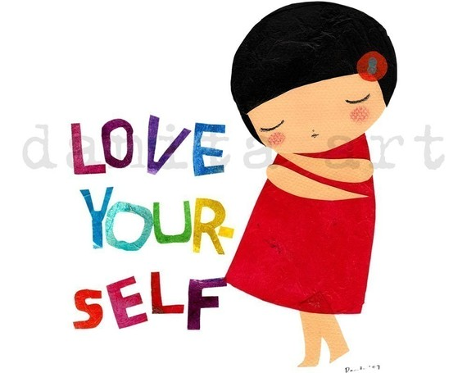
Ten tips to higher self-esteem

- Be kind to yourself

- Praise yourself for a job well done

- Don't be hard on yourself when things haven't turned out well but ask yourself what you can learn from this

- Set achievable goals

- Do things that make you feel good about yourself, either for yourself or someone else

- Be realistic and notice your good points

- Ask yourself if there is anything you can do about the things you don't like about yourself

- Learn & practice assertive skills

- Monitor your self-talk

- Try to master effective communication

Confidence boosters
Self confidence is a mixture of how we feel about ourselves and how we behave. Feeling confident enables us to relate openly and fully with others. All of us lack confidence in one way or another but we can help ourselves and make changes.
Remember: No one is confident all of the time in all situations. We all have times when we do not feel confident but we can believe in ourselves
Ten Top Tips
- Change the way you talk to yourself - Ban negative self talk
- Stop apologizing for yourself - "It’s only me", "I know it’s silly of me...."
- Get to know yourself better. Self-awareness is a basic requirement for confidence. It enables us to trust our own feelings and behaviour.
- Start being kind to yourself
- Care thoughtfully about your body
- Stimulate your mind
- Learn to relax
- Become more aware of non-verbal communication.
- Be prepared - contingency planning
- Organise your time

Be Posture Perfect:
- Stand with your feet hip-width apart
- Starting with your pelvis, pull your tummy muscles in and up towards your chest
- Give your shoulders a good shrug to help relieve tension, then gently roll your shoulders back
- Imagine your neck is lengthening, but keep your chin tucked in a little and look straight ahead
- Finally, imagine that an invisible thread is holding you in place - running from the crown of your head, through your body and down to the floor
- Remember to walk with a spring in your step!

People who stand tall ooze confidence - So can you!

Feel good about yourself
Make a list of all your good qualities - no matter what that might be. On a bad day, remembering your good points can shift you into a more positive mood
Turn negatives into positives. It’s easy to be self critical and put yourself down. An example being if you look in the mirror at yourself, instead of thinking "I've got big hips" think "I've got great curves" The more you say it the more you'll believe it.
If you'd like to lose weight or tone up, summer is often the best time to start an exercise routine. Feeling good about the way you look should help your self-esteem.
Get up a few minutes early
Don't hit the snooze button - even if it is a grey and rainy day. Use the time to:
Walk (at least part of the way) to work instead of driving or taking public transport. Walking is great exercise and it's free! You can tone up, get fresh air. Plan your day or just day dream, all at the same time.
Pamper yourself in the bath or shower Spend more time with your family.
Get to the gym. Try to exercise 3 times a week for about 20 minutes. If you feel confident about how you look you will have more self-esteem.
Sit down and eat a health breakfast, much better than dashing out of the house on an empty stomach. Our bodies are working most efficiently at this time of day so a good meal will give you lots of energy and help you feel better. Try to include fresh fruit, cereal with yoghurt or skimmed milk.
Try 1O minutes of meditation to help you relax and prepare for the coming day.
Prepare a healthy packed lunch, you'll save money and know exactly what you are eating.
Do those household chores that you'd usually leave until the week end.
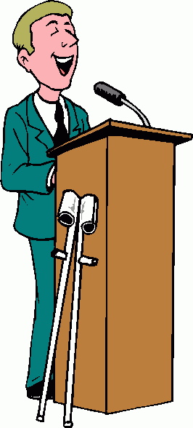

If you really cannot get out of bed, why not wake up to a current news station. Help to get your brain active. Some research shows that the more active your brain is during your first waking hours, the better your brain performs during the rest of the day.
These are just some tips to help your body feel better, help boost your self-esteem about how you feel about yourself.

Assertive Power
Assertiveness is form of behaving in a mature way in a difficult situation. It is a way of communicating how we feel about a situation and what we would like to happen. In order to do this we have to be clear ourselves.
We have to know what we are feeling and know what we would like to happen. We have to give the other person a chance to say what he or she feels and what they would like to happen.
We have to be able to communicate with that person to put our own views across. By being clear about what we feel and would like, we are more able to discuss the issue and reach a joint agreement.

The Four Pillars of Assertiveness
- Self-esteem & confidence: feeling good about yourself

- Self knowledge: asking yourself how you feel about a situation and what you would like to happen

- Respect for others: listening carefully to the other person's feelings and needs

- Clear communication: telling the other person you understand what they feel & want, and then telling them clearly what you feel & want.

Behaving assertively makes you think about yourself but not in a selfish way. As you start to behave this way you will begin to feel:
Good about yourself, acknowledge the things you are good at doing, rate yourself, accept praise and handle criticism, believe in yourself, take responsibility for yourself, ask for what you want, allow yourself to make mistakes, change your mind, recognise your responsibility to others.
Learning to behave assertively will help your self-esteem and confidence grow and strengthen.

Effective Communication
This is an important behaviour. One that is essential for high self-esteem and confidence. Communication in a clear, open manner is likely to help you feel good about yourself.
Be clear: tell other people how you feel in a positive, assertive manner.
Not being clear leaves others guessing what you mean, perhaps wrongly. It may put a strain on the relationship or create misunderstandings and confusion for all involved.
Listen
Listen to what others have to say, show them that you are listening, maintain comfortable eye contact, let them know that have heard them. If you didn't understand something they said, say so and ask them to clarify what they mean. If you can show you are listening to others they will be more likely to listen to you.
Validate
This means to accept what someone is saying about their feelings. You could say something like, "I can see you are quite upset by that." You may not agree with them but you are accepting that is how they feel. It offers respect to the other person.
To accept another person's feelings, even if they are not how you feel, will make is more likely that they will listen to you and accept your feelings.

We feel much better about ourselves when we communicate well with others. Understanding and being understood.

A Checklist for effective communication

  - Remain relaxed
  - Maintain eye contact
  - Smile and nod (non-verbal prompts)
  - Say what is on your mind
  - Remain assertive (not passive or aggressive)
  - Let the other person finish talking
  - Try and empathize with and understand the other person
  - Contribute to conversations
  - Ask questions about and of others
  - Ask for others opinions
  - Admit when you are wrong
  - Accept constructive criticism
  - Always look for a solution

If you can practice and achieve good communication you are well on your way to a higher level of self-esteem and confidence

References:
Bretch G – Sorting out self-esteem, Prentis Hall: Australia 1996
Walmsley C – Assertiveness, BBC Books London 1991
Acland & Floyer – Perfect people skills, Arrow Books : Australia 1999
Bupa Website

